Here follows a sample of my full NGC observation tables (6.5 Mb). It is an excel database with many thousands of entries. You start in the bottom line selecting the worksheet corresponding with the type of objects you want cataloged. They are marked as galaxies - open clusters - nebulae - globulars - planetaries ect. Then you will notice that when you move your mouse above the first line on the names of the columns you will have a pop-up box describing what excatly this column shows. When you hover your mouse above the first column entries where the object names are, a text pops up including all descriptions I have found on the individual object, plus the source of this knowledge. If the 'seen' column is marked with a '+' it means that I have actually seen this object, and a text appears with my seeing impressions on it. Date, telescope, sky's transparency, observation spot and altitude are also stated for this observation.
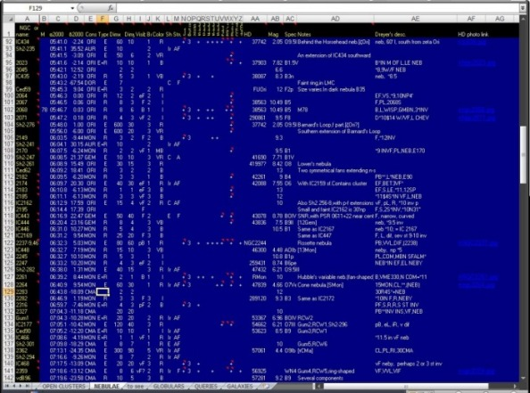
There are also some useful macro's included, turning the document into a full astronomical database software allowing you to add or delete entries and organise your own observations:
1) NGC finder (seen below): You enter the NGC number or scroll up and down the database and you see in one card the full objects properties. Knowledgebase descriptions, my observational descriptions, and all other cataloged data. You are able to add your own descriptions and observations as well.
2) Querry composer: To automatically build-up catalogs of available objects to see in a particular night. You have the options to narrow your search in specific coordinates (from - to) in Right Ascension and Declination, upper and lower visual magnitude, ect. Perfect for organising an observing session beforehands.
3) Text exporter to transform everything in simple text files. I did this in order to have all notes exported in mobile devices, since mobile excel files do not allow you to see the notes included in individual cells.
