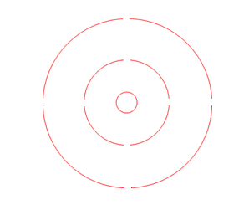
TELRAD 4, 2 AND 0.5 DEGREES

