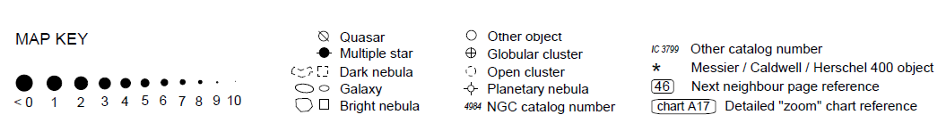
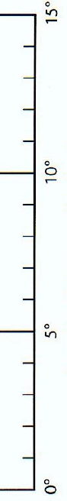

DEEP SKY HUNTER
STAR ATLAS

