A Brief Guide to Observing the Planet Venus
November 24, 2016 By Brian Ventrudo

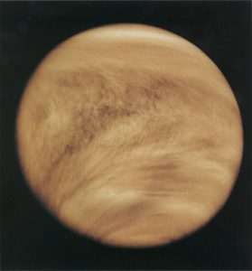
The planet Venus is the third brightest object in our skies after the Sun and the Moon. Known since the first humans turned their gaze to the sky, the striking appearance of Venus compelled the ancient Greeks and Romans to name the planet after the goddess of love and beauty. Other cultures, including the Sumerians and the Pawnee in North America also linked this brilliant planet to objects of feminine beauty. The ancient Mayans had a particular interest in Venus and built an observatory at Chichen Itza to, among other things, precisely measure the position of the planet, and some aspects of the Mayan calendar are based on the motions of Venus. While Venus reveals little detail in a telescope, it grows and shrinks and goes through a series of phases similar to the Moon, and comes closer to Earth than any other planet. Here’s a little background on the planet Venus and a few tips to help you see the planet for yourself and understand its apparitions and motion in our skies.

A Beautiful But Hellish World
In size and mass, Venus remarkably resembles our own planet. Its diameter is about 12,100 km, just a few percent smaller than Earth’s. It has a mass about 82% that of Earth and a surface gravity about 90% that of Earth. This superficial likeness to our planet caused many astronomers and storytellers from the 17th to the 20th centuries to speculate on the existence of life on Venus. Since the planet is a little closer to the Sun and appears to be covered with clouds, many thought Venus must be similar to a tropical rainforest and might be quite hospitable to rich plant life and perhaps even to intelligent beings. An 18th century French philosopher suggested Venus might resemble the then-new French colony of Tahiti. The Nobel laureate Svante Arrhenius in 1918 speculated the planet was a giant wet nursery of short-lived plant life. Even as late as 1960, the science writer G. E. Pendray, a founder of the American Rocket Society, hoped that Venus might “turn out to be a wonderful place to live, like Florida all over”.
But no. Starting in 1961, space probes were sent to fly by, and in a few cases, orbit or land on the planet. Mariner 2 made a successful flyby in 1962, as did many of the ambitious Russian Venera missions from the 1960’s through the early 1980’s. A closer look at Venus with space probes and with radar observations quickly shattered the illusion that the surface of Venus is anything like that of Earth. Venus has the densest atmosphere of the four rocky inner planets of our solar system. Its atmospheric pressure is almost 100x that of Earth, and its surface temperature is a steady 460ºC (about 860ºF), more than hot enough to melt lead. That makes the planet the hottest in the solar system, even hotter than sun-baked Mercury. At its surface, at least, Venus is more hell than paradise.
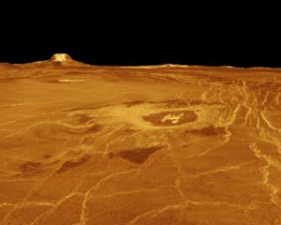
A radar rendition of the surface of Venus.
Move about 50 kilometers above the surface of Venus, however, and it’s a different story. Here the atmosphere is mostly carbon dioxide, the Sun shines brightly, the pressure is similar to Earth, and the temperature a much more reasonable 75°C, altogether a much more benign and Earth-like environment. While Mars and the Moon get most of the attention for future manned exploration, some imaginative souls at NASA have dreamed up a concept of sending astronauts to explore the upper atmosphere of Venus. This short video shows how it might be done.

Venus as the “Morning Star” and “Evening Star”
Like Mercury, Venus is a so-called inferior planet, which means its orbit lies inside the orbit of Earth. That has implications for us Earthbound stargazers. For one, it means Venus and Mercury never stray far east or west of the Sun. Venus, for example, always lies within 47.8º of the Sun and either rises before the Sun in the east, when it is called the “morning star”, or sets after the Sun in the west, when it is called the “evening star”. As Earth and Venus make their way around the Sun, speedier Venus will sometimes pass between the Earth and Sun, a position known as inferior conjunction. It then moves westward into the morning sky, rising higher each week until it reaches greatest western elongation. It then appears to move back towards the Sun and, when it passes behind the Sun, or nearly so, reaches superior conjunction. Then it appears again in the evening sky, rising and moving eastward each week until it reaches greatest eastern elongation. It then moves back towards the Sun and repeats the whole process. It takes Venus 224.7 days to move around the Sun, but because of the motion of the Earth, it takes about 584 days for Venus to move through one complete cycle from one inferior conjunction to the next.
The image below shows the relative positions of Venus to Earth and will help you visualize its position and motion in our skies.

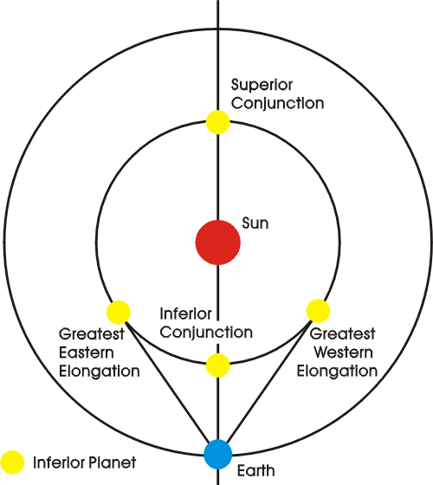
The positions of the inferior planets Venus and Mercury as seen from Earth.

The Phases of Venus
Despite its nearness, brightness, and large apparent size, Venus reveals little detail to telescopic observers. But because it’s inside the orbit of Earth, the planet does appear to cycle through phases much like the Moon. The image below shows the geometry that leads to the phases.
When Venus, for example, lies on the far side of the Sun from Earth, the planet is fully illuminated from our point of view. But its disk is small, just 10″ across, because the planet is nearly 300 million kilometers away. When Venus is almost closest to Earth, just adjacent to the Sun in our sky, it’s about 50-60 million kilometers away. That’s when it appears as a slender crescent with a disk 40″-50″ across, about as apparently large as the planet Jupiter. In between these extremes, the planet can appear half-lit, like the first-quarter Moon, and in various gibbous phases as it cycles through its 584 day period. Venus appears brightest in the crescent phase because, although it is only partly illuminated, it is much closer to Earth so the total visible surface area is larger than when the planet is fully illuminated.
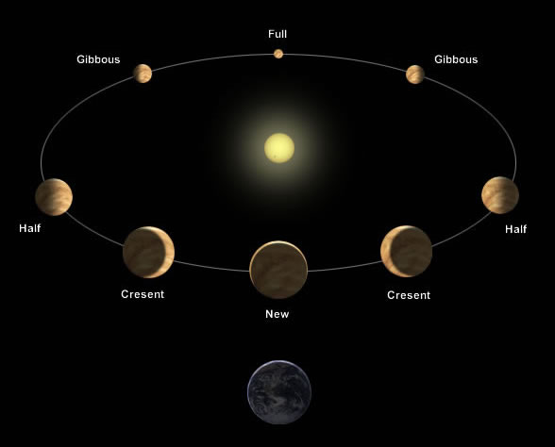
The geometry of the phases of Venus
The phases of Venus (and Mercury) are easily visible in a small telescope at 50x or more, and it’s great fun to observe the changes of these phases from month to month. When observing the planet near inferior or superior conjunction, take care you do not accidentally catch sight of the Sun, especially through a telescope.
The phases of Venus also have historical cosmological significance. How? Before these phases of Mercury and Venus were discovered in a telescope by Galileo in 1610, there was lively debate on whether the Earth or Sun was the center of the solar system. By the early 1600s, there was evidence for and against both views. But there is no reasonable explanation for Venus (and Mercury) to display a complete cycle of phases in an Earth-centered solar system. However, with the Sun at the center, and Earth orbiting the Sun outside the orbit of Venus, the phases, as mentioned above, are easy to explain. So when you see the phases of Venus and Mercury in your telescope, you are seeing strong evidence of a Sun-centered solar system.
Some unconfirmed reports, in modern and ancient times, suggest some sharp-eyed observers have observed the extremely slim and bright crescent phases of Venus without optical aid! The Mesopotamian goddess Ishtar, who was represented by what we call the planet Venus, is described in ancient cuneiform texts as having “horns”.
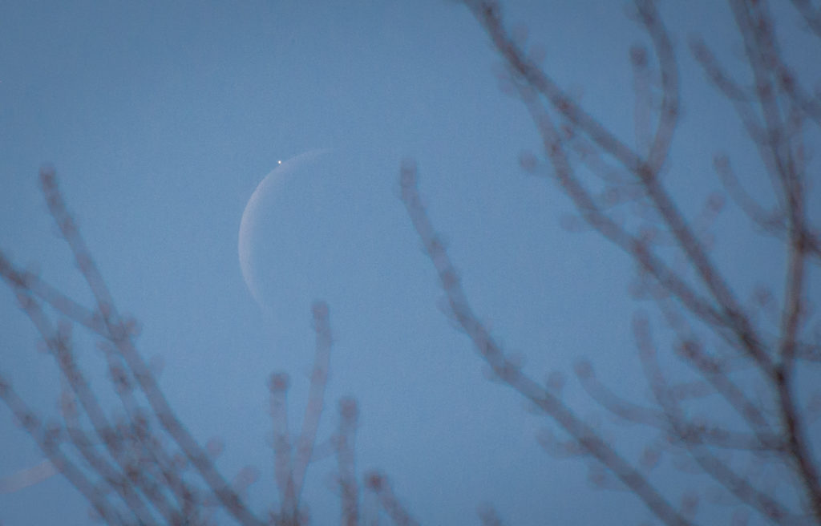
Venus just before it passes behind the Moon in daylight on Dec. 7, 2015.

Observing Venus
Venus is often prominent along the ecliptic at sunrise or sunset and often results in photogenic conjunctions with other bright planets and with the crescent Moon. Such appearances require no optics to enjoy and are wonderful events to share with non-stargazers to get them interested in amateur astronomy. In many cases, binoculars can enhance the view if Venus gets within a few degrees of the Moon or another planet.
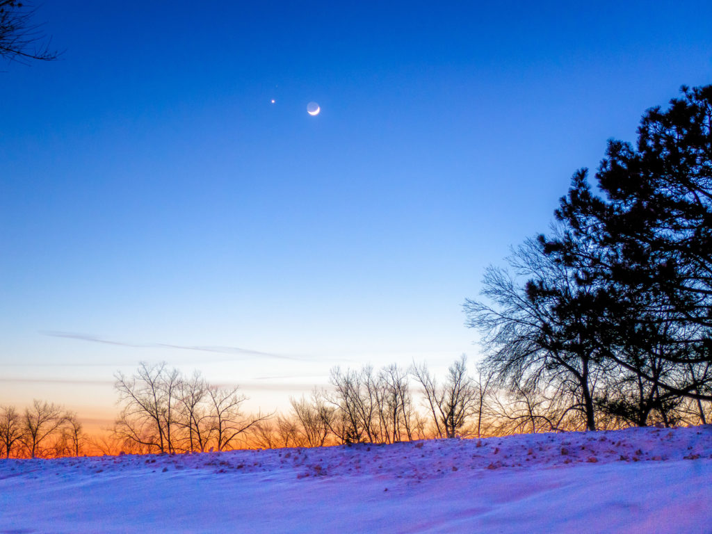
The crescent Moon, Venus, and much fainter Mars. Click on image to open in a new window.
At its brightest in dark sky well after sunset, when it reaches a magnitude as bright as -4.8, the planet seems close at hand, almost palpable, and can cast a shadow onto dark ground. And Venus is not particularly difficult to see during the day if you know where to look. If you have a go-to telescope, or if Venus is close to the Moon which acts as a marker, you can easily spot Venus during the day with small optics, and even with your unaided eye.
Many amateur observers have reported seeing in a telescope at high magnification a faint glow on the darkened section of the face of Venus. This is the “ashen glow”. The Moon displays a similar glow called “Earthshine”, which is simply sunlight reflected off the Earth and onto the dark surface of the Moon. You can see this especially on the Moon when it is a crescent. But Earthshine is not the cause of ashen glow on Venus; the Earth is too far away. The effect may be caused by glow in the atmosphere, or it may simply be an optical illusion.
And it IS possible to see some structure in the clouds of Venus with an amateur telescope. You need steady skies, high magnification and a good scope, and a violet filter on your eyepiece to pass only short wavelengths. It’s not an easy project, but it is worthwhile because you will see something rare and quite beautiful. This image from John Chumack gives you a taste of what can be seen and imaged.

Seeing Venus in 2017
As 2016 comes to an end, the planet Venus plays its role as the “evening star”. The planet is brilliant and prominent in the western sky as the Sun sinks, in both the northern and southern hemispheres. By the end of the year, the planet brightens to magnitude -4.4 and outshines everything in the sky except for the Sun and Moon. In December 2016, the planet moves eastward from Sagittarius into Capricornus, and the slender crescent Moon brushes by on Dec. 2-3.
On January 12, 2017, Venus reaches greatest eastern elongation some 47.1° from the Sun. It will be about 50% illuminated. As a remarkable coincidence, on the same day, the planet comes within 1/2 a degree of the planet Neptune. Both planets will fit in the same field of view of a small telescope, though Neptune will present a tiny 2.2″ disk compared to the 25″-wide disk of Venus. Venus will also outshine Neptune by a factor of 30,000!
Venus moves towards the Sun for the rest of the spring of 2017, grows in size as it turns into an increasingly slender crescent, and reaches inferior conjunction on March 25. On and around this day, because of the tilt of the orbit of Venus and Earth, Venus does not pass in front of the Sun, but appears about 8° north of the Sun. It will be an impressive 59.3″ across, magnitude -4.2, and appear just 1% illuminated. If you are VERY careful not to accidentally look at the Sun, you can spot the planet with a small telescope during the daylight hours.
Then Venus moves into the morning sky and stays there for the rest of 2017. Here it makes a fine pairing with the waning crescent Moon on May 22, with Uranus on June 3 when the two planets are about 1.8º apart, and with the Moon again on July 20. On October 5, 2017, Venus will come within 1/4 degree of the planet Mars– an impressive event in the sky before sunrise. And on November 13, bright Jupiter comes within about 1/4 to 1/3 of a degree from Venus, depending on your location. The two will be just 14º from the Sun, so you will need a clear view of the eastern horizon before sunrise to see the pair. And if you’re ambitious, you can track and observe the two planets very close together during the daylight hours on Nov. 13.
Venus then sinks into the east for the rest of 2017 and becomes lost to the Sun’s glare before reaching superior conjunction in early 2018. Then it repeats the cycle again.

