A/A | Κατασ/στής | Εστιακή  Απόσταση | Διάμετρος | Πεδίο | Τιμή (€) | φωτό
1 | Antares  SPEERS-WALER | 30mm | 2 in | 68° AFOV | 60 € | 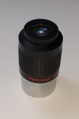
2 | Antares  SPEERS-WALER | 18mm | 1 1/4in | 74° AFOV | 60 € | 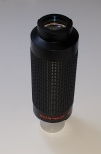
3 | Antares  SPEERS-WALER | 14mm | 1 1/4in | 73° AFOV | 60 € | 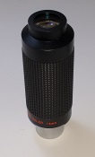
4 | Antares  SPEERS-WALER | 12mm | 1 1/4in | 80° AFOV | 60 € | 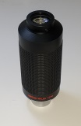
5 | Antares  SPEERS-WALER | 10mm | 1 1/4in | 70° AFOV | 60 € | 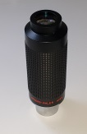
6 | Antares  SPEERS-WALER | 7mm | 1 1/4in | 84° AFOV | 60 € | 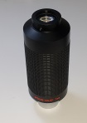
7 | TELE-VUE | 20mm  NAGLER TYPE2 | 2 in | 82° AFOV | 240 € | 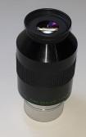
8 | TELE-VUE | 4mm  Radian | 1 1/4in | 60° AFOV | 130 € | 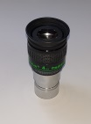
9 | UNIVERSSITY | 32mm  KONIG-II | 2 in | 60° AFOV | 70 € | 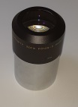
10 | MEADE | 40mm  SUPER PLOSSL | 1 1/4in | 52° AFOV | 60 € | 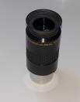
11 | MEADE | 32mm  SUPER PLOSSL | 1 1/4in | 52° AFOV | 60 € | 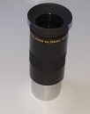
12 | MEADE | 26mm  SUPER PLOSSL | 1 1/4in | 52° AFOV | 60 € | 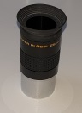
13 | MEADE | 26mm  SUPER PLOSSL | 1 1/4in | 52° AFOV | 50 € | 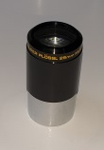
14 | CELESTRON | 26mm  PLOSSL | 1 1/4in | 52° AFOV | 50 € | 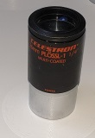
15 | CELESTRON | 25mm  Kelner | 1 1/4in | 40° AFOV | 50 € | 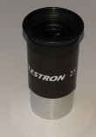
16 | CELESTRON | 9mm  PLOSSL | 1 1/4in | 52° AFOV | 40 € | 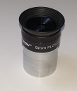
17 | CELESTRON | 4mm  PLOSSL | 1 1/4in | 52° AFOV | 40 € | 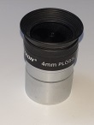
18 | CELESTRON | H20mm | 1 1/4in | 35° AFOV | 30 € | 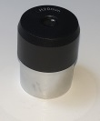
19 | UNIVERSSITY | 24mm  KONIG-II | 1 1/4in | 60° AFOV | 60 € | 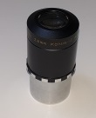
20 | UNIVERSSITY | 16mm  KONIG-II | 1 1/4in | 60° AFOV | 50 € | 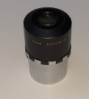
21 | UNIVERSSITY | 12mm  KONIG-II | 1 1/4in | 60° AFOV | 40 € | 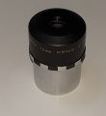
22 | UNIVERSSITY | 8mm  KONIG-II | 1 1/4in | 60° AFOV | 40 € | 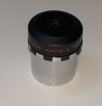
23 | UNIVERSSITY | 6,5mm  KONIG-II | 1 1/4in | 60° AFOV | 40 € | 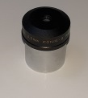
24 | CELESTRON | BARLOW 2X | 1 1/4in |  | 50 € | 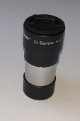
25 | SKY-WATCHER | BARLOW 2X | 1 1/4in |  | 40 € | 